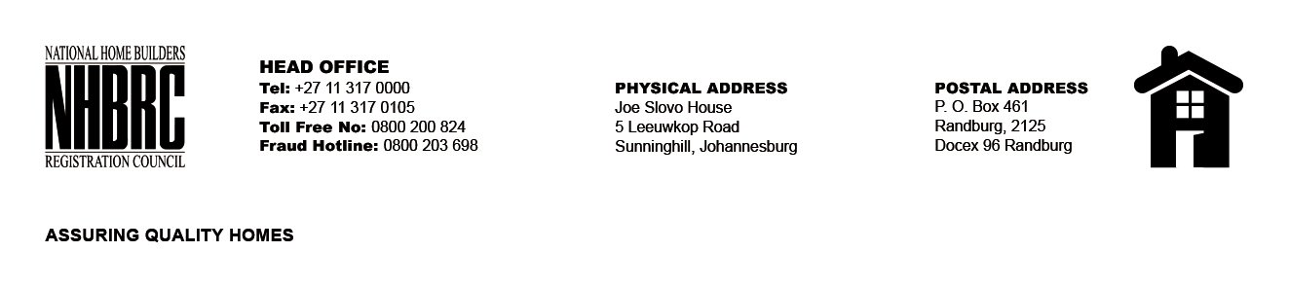

OPENING REGISTER

BID NUMBER : NHBRC 13/2025
CLOSING DATE: 25 FEBRUARY 2026 @ 11h00

BID DESCRIPTION: REQUEST FOR PROPOSALS: APPOINTMENT OF A SUITABLE SERVICE PROVIDER FOR SHORT TERM INSURANCE BROKERING AND CLAIMS MANAGEMENT SERVICES FOR A PERIOD OF THREE YEARS
NO. | NAME OF BIDDERS | PRICE (INCL. VAT)
1. | Kunene Makopo Risk Solutions | R 1 305 725.16
2. | Mmela Financial Services (Pty) Ltd | R 804 926.00
3. | Elgatone Assurance Brokers | R 964 820.92
4. | Moso Consulting Services | R 1 612 327.99
5. | African Dawn Risk Solutions | R 1 503 924.92
6. | Mpumelelo Financial Services | R 984 690.74
7. | Shomang Brokers cc | R 1 976 310.08
8. | African Risk and Insurance Services | R 905 319.36
9. | Maksure Risk Solutions | R 962 431.93
10. | Sankofa Insurance Brokers | R 988 683.43
TOTAL BIDS RECEIVED |  | 10

