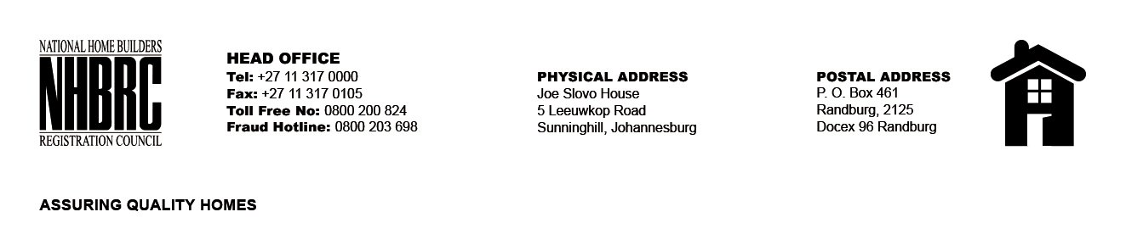

OPENING REGISTER

BID NUMBER : NHBRC 09/2025 (PORT ELIZABETH. EASTERN CAPE)
CLOSING DATE : 30 January 2026 @ 11h00

BID DESCRIPTION: REQUEST FOR PROPOSALS: APPOINTMENT OF A PANEL OF RECORDING AND TRANSCRIBING SERVICE PROVIDERS FOR THE NATIONAL HOME BUILDING REGISTRATION COUNCIL (NHBRC) FOR A PERIOD OF (05) YEARS.

NO. | NAME OF BIDDERS | PRICE (INCL. VAT)
1. | Telabo Consulting | N/A
2. | Mentemore Consulting (Pty) Ltd | N/A
3. | Afriway Biziness Solutions (Pty) Ltd | N/A
4. | Gauteng Transcribers cc | N/A
TOTAL BIDS RECEIVED |  | 04

