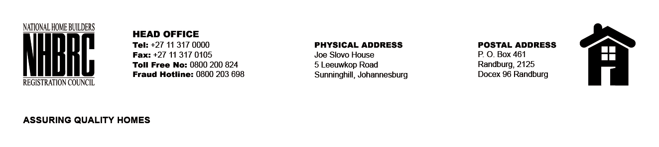

BID NUMBER: NHBRC 06/2025
CLOSING DATE: 18 SEPTEMBER 2025 @ 11H00

BID DESCRIPTION: REQUEST FOR PROPOSALS: APPOINTMENT OF A SUITABLE SERVICE PROVIDER TO PROVIDE HYGIENE SERVICES AND SUPPLY CONSUMABLES TO THE NHBRC (HEAD OFFICE – SUNNINGHILL OFFICE) FOR A PERIOD OF THREE (03) YEARS.

NO. | NAME OF BIDDER | PRICE
1. | CRAISON FACILITIES SOLUTIONS | R3 063 527.01
2. | MLILWANA (PTY) LTD | R3 584 403.90
3. | MASANA HYGIENE SERVICES | R2 940 931.95
4. | WPM CONSULTING (PTY) LTD | R3 505 566.45
5. | LEGOBOLE ENTERPRISE (PTY) LTD | R3 309 692.64
6. | OKS INVESTMENT 2009 | R2 701 264.99
7. | NEXUS INNOVATIVE SOLUTIONS (PTY) LTD | R4 931 752.17
8. | KAMESO TOTAL HYGIENE SERVICES | R2 906 549.00
9. | MONABO HYGIENE SERVICES | R3 658 402.52
10. | ARM MEGA CORP PROJECTS (PTY) LTD | R26 260 475.11
11. | BLUEPRINT SECURITY SERVICES | R20 201 162.59
12. | TINEY CLEANING SERVICES 2 | R2 919 473.72
13. | 5 STAR CLEANING SERVICES | R2 072 655.00
14. | KGATISI TRADING CC | R4 311 572.90
15. | NOZINGA GROUP T/A IFM SOLUTIONS | R2 814 799.93
16. | GLAMARO (PTY) LTD | R3 611 204.00
17. | FSG CLEANING SERVICES (PTY) LTD | R4 232 466.76
18. | AQUEOUS CLEANING SERVICES | R3 934 534.42
19. | CHILLO GROUP | R44 371 071.57
20. | INTERVECTOR (PTY) LTD | NO PRICE
21. | ZAKHI AFRICA (PTY) LTD | R4 243 972.65
22. | LIRORA TRADING | R3 275 000.00
23. | VIABLE WORK (PTY) LTD | R3 275 000.00
24. | MAJODINA GROUP (PTY) LTD | R2 708 688.84
25. | KUSILE FACILITIES MANAGEMENT (PTY) LTD | R2 995 179.65
26. | FUMIGATION WORK CC | R2 320 263.13
27. | SSG CLEANING (PTY) LTD | R2 822920.13
TOTAL: 27

