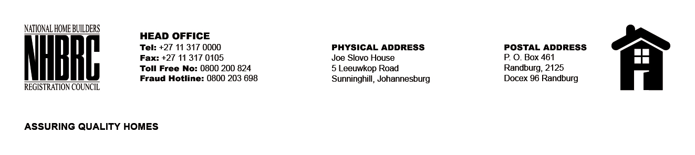

OPENING REGISTER

BID NUMBER : NHBRC 03/2023_Witbank Office Lease Re-advert
CLOSING DATE : 01 February 2024 @ 11h00

BID DESCRIPTION: REQUEST FOR PROPOSALS: APPOINTMENT OF A SERVICE
PROVIDE TO PROVIDE SUITABLE OFFICE ACCOMMODATION AND PARKING
FACILITIES FOR THE WITBANK OFFICE FOR A LEASE PERIOD OF FIVE (05) YEARS.

NO. | NAME OF BIDDERS | PRICE (INCL. VAT)
1. | Baithusi Trading 134cc | R12 616 494.41 Rental Cost  R 172 212.50 Operational Cost
2. | Nozulu Investments (Pty) Ltd | R 4 618 754.18
3. | Maria Margaret Mthimunye | R 5 771 216.35
4. | Witbank Nocom cc t/a De Bruyn Commercial Property Brokers | R 4 823 393.00
5. | Serbean Manufacturing t/a Witbank Rentals | R 2 703 267.95
6. | Tupac Business Enterprise cc | R 2 347 813.71
TOTAL BIDS RECEIVED |  | 06

