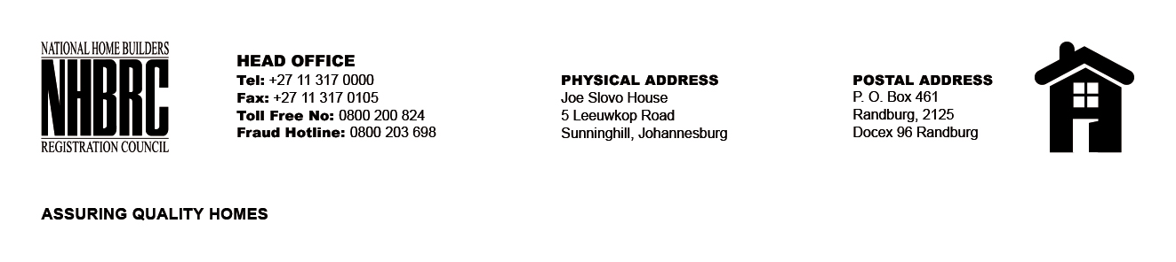

BID NUMBER: NHBRC 11/2023
CLOSING DATE: 05 FEBRUARY 2024 @ 11H00

BID DESCRIPTION: REQUEST FOR PROPOSALS: APPOINTMENT OF A PANEL OF SERVICE PROVIDERS TO PERFORM RESIDENTIAL INSPECTORATE ON BEHALF OF THE NHBRC FOR A PERIOD OF FIVE (5) YEARS
NORTHERN CAPE, KIMBERLEY

NO. | NAME OF BIDDER
1. | RIBICON CONSULTING GROUP
2. | TSEKWANE INVESTMENTS (PTY) LTD
3. | V3 CONSULTING ENGINEERS (PTY) LTD
4. | TTE GROUPS (PTY) LTD
5. | LUTAK CONSULTING
6. | LYMA CONSULTING ENGINEERS
7. | SHAWENI CONSULTING ENGINEERS (PTY) LTD
8. | CIVIL SENSE CONSULTING
9. | UNDASA PROJECT PARTNERS (PTY) LTD
10. | EXILITE 349cc
11. | KRMS ARCHITECTS
12. | THEMANE MANAGEMENT CONSULTING (PTY) LTD
13. | MJT CONSULTING ENGINEERS 01 (PTY) LTD
14. | MGIBA CONSULTING
TOTAL: 14

