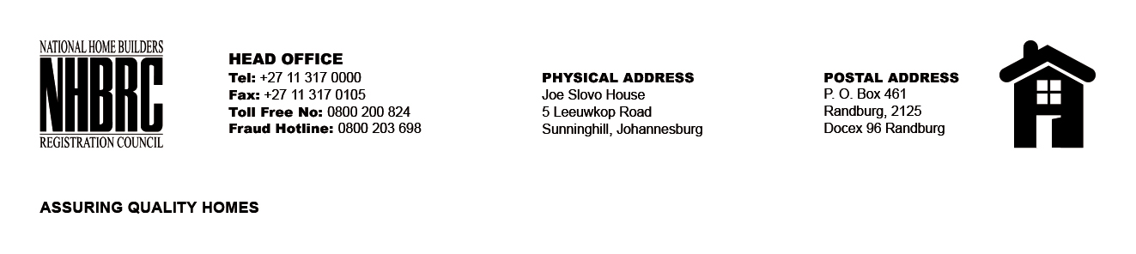

BID NUMBER: NHBRC 10/2023
CLOSING DATE: 23 JANUARY 2024 @ 11H00

BID DESCRIPTION: REQUEST FOR PROPOSALS: ESTABLISHMENT OF A PANEL OF SERVICE PROVIDERS TO PERFORM CONSTRUCTION MATERIAL TESTING SERVICES TO THE NHBRC FOR A PERIOD OF FIVE (5) YEARS

NO. | NAME OF BIDDER
1. | KG SHARP LABORATORIES
2. | SOILEONIX (PTY) LTD
3. | CIVILAB (PTY) LTD
TOTAL: 3

