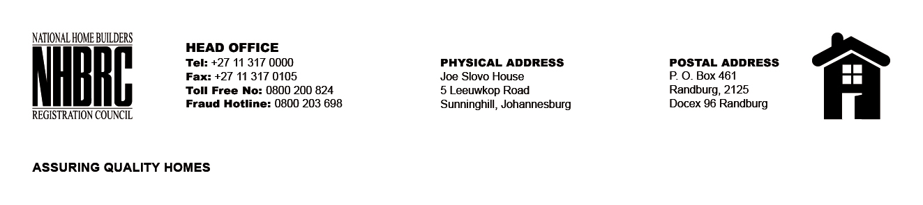

OPENING REGISTER

BID NUMBER : NHBRC 01/2023: NC KIMBERLY
CLOSING DATE : 24 July 2023 @ 11H00

BID DESCRIPTION: APPOINTMENT TO THE NATIONAL HOME BUILDERS REGISTRATION COUNCIL’S (“NHBRC”) PANEL OF ATTORNEYS FOR A PERIOD OF FIVE (05) YEARS.

NO. | NAME OF BIDDERS
1. | ZWELIBANZI NGOUOU INCORPORATED
2. | MODIBOA ATTORNEYS INC
3. | MADIBA/ MOTSAI/ MASITENYANE/ GAITHIRO ATTORNEYS
4. | ROBERT CHARLES ATTORNEYS
5. | NQWAKO MAKHETHA ATTORNEYS
Total 5 Bids

