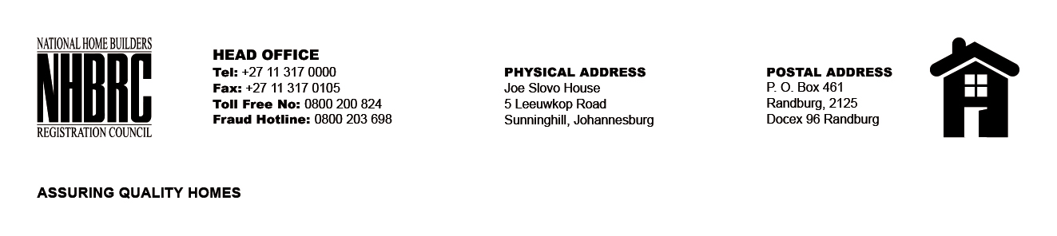

OPENING REGISTER

BID NUMBER : NHBRC 01/2022: (NorthWest)
CLOSING DATE : 12 April 2023 @ 11H00

BID DESCRIPTION: APPOINTMENT OF A PANEL FOR THE DESIGN, SUPPLY, AND INSTALLATION OF PROJECT (CONSTRUCTION) SIGNAGE BOARDS FOR A PERIOD OF THREE YEARS.

NO. | NAME OF BIDDERS
1. | Mudau Pictures Framers T/A FrameFun
2. | Pink Power Past
Total 2 Bids

