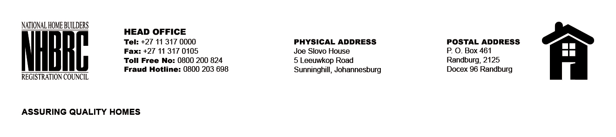

OPENING REGISTER

BID NUMBER : NHBRC 01/2022: (Limpopo)
CLOSING DATE : 14 April 2023 @ 11H00

BID DESCRIPTION: APPOINTMENT OF A PANEL FOR THE DESIGN, SUPPLY, AND INSTALLATION OF PROJECT (CONSTRUCTION) SIGNAGE BOARDS FOR A PERIOD OF THREE YEARS.

NO. | NAME OF BIDDERS
1. | AMO Dynamic Printing And Services
2. | Mudau Picture Framers T/A FrameFun
3. | Nano Holdings (PTY) LTD
4. | Ramodiba Security and Projects
5. | TP BUSINESS MANAGEMENT
Total 5 Bids

