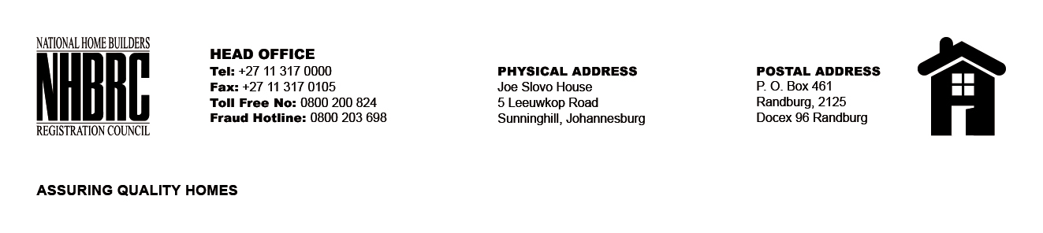

OPENING REGISTER

BID NUMBER : NHBRC 01/2022: (Gauteng)
CLOSING DATE : 12 April 2023 @ 11H00

BID DESCRIPTION: APPOINTMENT OF A PANEL FOR THE DESIGN, SUPPLY, AND INSTALLATION OF PROJECT (CONSTRUCTION) SIGNAGE BOARDS FOR A PERIOD OF THREE YEARS.

NO. | NAME OF BIDDERS
1. | XAN M HOLDINGS (PTY) LTD
2. | Genie Con (PTY) LTD
3. | Nkhophele Holdings
4. | Totobela Trading And Projects
5. | Talortec
6. | MJ Innovative Solutions
7. | Procost & Associates
8. | Mudau FrameFun Digital Printing
Total 8 Bids

