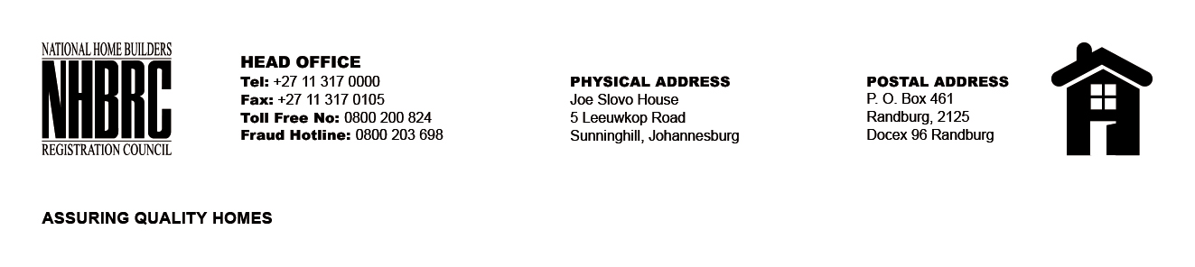

OPENING REGISTER

BID NUMBER : NHBRC 01/2022: (Durban KZN)
CLOSING DATE : 12 April 2023 @ 11H00

BID DESCRIPTION: APPOINTMENT OF A PANEL FOR THE DESIGN, SUPPLY, AND INSTALLATION OF PROJECT (CONSTRUCTION) SIGNAGE BOARDS FOR A PERIOD OF THREE YEARS.

NO. | NAME OF BIDDERS
1. | Mudau Picture Framers T/A FrameFun
2. | Mysitoz Trading and Projects
3. | Mthandwabantu Trading Enterprise
4. | Alondwaphelele (Pty) Ltd
5. | Zuwon Consultants
6. | Athimthende Development services
7. | Duncoe Africa (Pty) Ltd
Total 7 Bids

