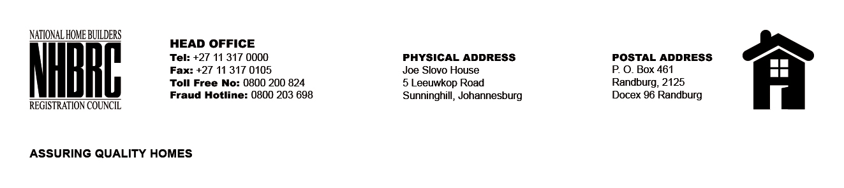

BID NUMBER: NHBRC 04/2023
CLOSING DATE: 17 AUGUST 2023 @ 11H00

BID DESCRIPTION: REQUEST FOR PROPOSALS: APPOINTMENT OF A PANEL OF INTERNAL AUDITORS TO THE NATIONAL HOME BUILDERS REGISTRATION COUNCIL (“NHBRC”) FOR A PERIOD OF THREE (03) YEARS. NORTHERN CAPE (KIMBERLY)

NO. | NAME OF BIDDER | PRICE (INCLUDING VAT)
1. | PANDELL CONSULTING | PER AG RATES
2. | SNG GRANT THORNTON
3. | SHUMBA INC
4. | SAMBA SOLUTIONS INC
5. | HTB CONSULTING
6. | RAKOMA AND ASSOCIATES INC
7. | LANDMARK ACCOUNTANTS AND
8. | PWC
9. | SAB & T CHARTERED ACCOUNTANTS INC
10. | MOLEFI BUSINESS EXPERTS CONSULTING (MBE)
TOTAL: 10

