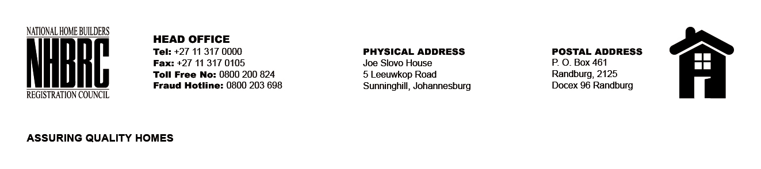

BID NUMBER: NHBRC 21/2019
CLOSING DATE: 22 NOVEMBER 2019 @ 11H00

BID DESCRIPTION: REQUEST FOR PROPOSALS: APPOINTMENT OF A SUITABLE SERVICE PROVIDER FOR THE ACCREDITATION OF THE NHBRC CONSTRUCTION MATERIALS TESTING LABORATORY AND ITS TESTING GEOTECHNICAL AND CIVIL METHODS FOR A PERIOD OF THREE (03) YEARS.

NO. | NAME OF BIDDER | PRICE
1 | MICHEM DYNAMICS PTY LTD | R 767 740.00
2 | ROADLAB LABORATORIES PTY LTD | PRICING AS PER LIST OF ITEMS
3 | BOLEBO CONSULTING PTY LTD | R 6 639 870.00
4 | NANGU INVESTMENTS PTY LTD | R 5 513 100.00
5 | SGS MATROLAB PTY LTD | R 975 821.00
TOTAL: 05

