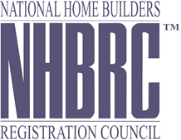
BID/RFP NUMBER: NHBRC 1122/2014 – CLOSING DATE: 25 March 2015

APPOINTMENT OF A SERVICE PROVIDER TO RENDER CORPORATE TRAVEL MANAGEMENT SERVICES TO THE NHBRC FOR A PERIOD OF THREE YEARS (36 MONTHS).
NO. | NAME OF BIDDER
1 | TWF Corporate Travel
2 | Rennies Travel
3 | Batsumi Travel
4 | Sure Travel
5 | XL Nexus Travel
6 | SALSA Tours “Proprietary” Limited
7 | Uniglobe Travel
8 | Wings Naledi Travel
9 | Atlantis Corporate Travel
10 | KMM Travel
11 | XL Travel By Arrangement
12 | Tourvest Travel Services
13 | Duma Travel
14 | Hambanathi Travel
15 | K Travel
TOTAL: 15

