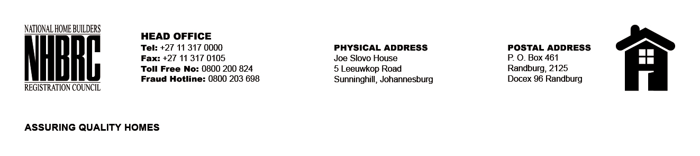

BID NUMBER: NHBRC 03/2023 GP TSHWANE RE-ADVERT 1
CLOSING DATE: 11 APRIL 2024 @ 11H00

BID DESCRIPTION: REQUEST FOR PROPOSALS: APPOINTMENT OF A SERVICE PROVIDER TO PROVIDE SUITABLE OFFICE ACCOMMODATION AND PARKING FACILITIES FOR TSHWANE OFFICE FOR A LEASE PERIOD OF FIVE (05) YEARS.

NO. | NAME OF BIDDER | PRICE (INCL. VAT)
1. | ALUTA INDUSTRIES | R35 997 785. 97
2. | MOWANA PROPERTIES | R13 875 582.56
3. | COLUMBIA FALLS PROPERTIES | R15 819 406.82
4. | DELTA PROPERTY FUND LIMITED (429 CHURCH STREET) | R9 773 531.01
5. | DELTA PROPERTY FUND LIMITED (277 VERMEULEN STREET) | R9 468 361.23
6. | SKG AFRICA (PTY) LTD | R13 028 936.91
TOTAL |  | 06

