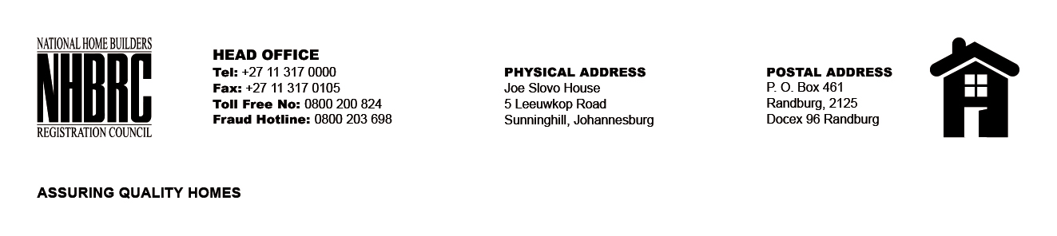

OPENING REGISTER

BID NUMBER : NHBRC 11/2023 Panel of Residential Inspectorate_ MP Nelspruit
CLOSING DATE : 02 February 2024 @ 11h00

BID DESCRIPTION: REQUEST FOR PROPOSALS: ESTABLISHMENT OF A PANEL OF SERVICE PROVIDERS TO PERFORM RESIDENTIAL INSPECTORATE SERVICES ON BEHALF OF THE NHBRC FOR A PERIOD OF FIVE (05) YEARS.

NO. | NAME OF BIDDERS
1. | C. Giyose and Associates
2. | Tsekwane Investment (Pty) Ltd
3. | Gudunkomo Investments & Consulting (Pty) Ltd
4. | Isiseko Engineers
5. | Mgiba Consulting
6. | Songomyama Trading
7. | Lutendo Property Group (Pty) Ltd
8. | Ukukhanya Consulting Engineers (Pty) Ltd
9. | Ndlovu Ngonyama (Pty) Ltd
10. | MJT Consulting Engineers 01 (Pty) Ltd
11. | TOBC Integrations (Pty) Ltd
12. | MGM Ngwenya Consulting Engineers
13. | Inhlakanipho Consultants (Pty) Ltd
14. | Sekothobs
15. | TN Molefe Consulting Services (Pty) Ltd
16. | HI End Group
17. | Exilite 349
18. | SCIP Engineering Group (Pty) Ltd
19. | Ratzoe Solutions and Projects
20. | JTP Consortium (Pty) Ltd
21. | Iconsult Engineers (Pty) Ltd
TOTAL BIDS RECEIVED: 21

