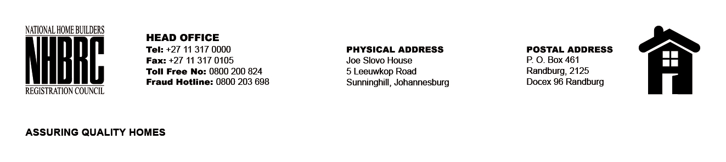

BID NUMBER: NHBRC 11/2023
CLOSING DATE: 06 FEBRUARY 2024 @ 11H00

BID DESCRIPTION: REQUEST FOR PROPOSALS: APPOINTMENT OF A PANEL OF SERVICE PROVIDERS TO PERFORM RESIDENTIAL INSPECTORATE ON BEHALF OF THE NHBRC FOR A PERIOD OF FIVE (5) YEARS
BLOEMFONTEIN, FREE STATE

NO. | NAME OF BIDDERS
1. | V3 CONSULTING ENGINEERS (PTY) LTD
2. | NDLOVU NGONYAMA (PTY) LTD
3. | KLOK ENGINEERING SERVICES (PTY) LTD
4. | THAPELO TLHAPANE HOLDINGS (PTY) LTD
5. | LYMA CONSULTING ENGINEERS
6. | MAKUNGANI TECHNICAL CONSULTANT
7. | PURIM CONSULTING (PTY) LTD
8. | MADHLAKULU TRADING & PROJECTS
9. | KATEMO GENERAL TRADING
10. | MPHATI AND ASSOCIATES (PTY) LTD
11. | TSEKWANE INVESTMENTS (PTY) LTD
12. | SADC PROJECT CONSULTING (PTY) LTD
13. | JTP CONSORTIUM (PTY) LTD
14. | ISISEKO ENGINEERS
15. | MGIBA CONSULTING
16. | MJT CONSULTING ENGINEERS 01 (PTY) LTD
17. | PRANA CONSULTNG (PTY) LTD
18. | THEMANE MANAGEMENT CONSULTING (PTY) LTD
19. | UNDASA PROJECT PARTNERS (PTY) LTD
20. | LELOKO LA BATHO
21. | LUTENDO PROPERTY GROUP (PTY) LTD
TOTAL: 21

