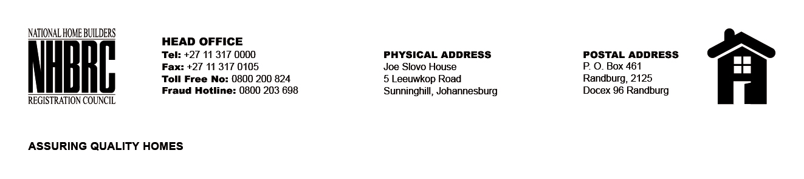

BID NUMBER: NHBRC 11/2023
CLOSING DATE: 01 FRBRUARY 2024 @ 11H00

BID DESCRIPTION: REQUEST FOR PROPOSALS: APPOINTMENT OF A PANEL OF SERVICE PROVIDERS TO PERFORM RESIDENTIAL INSPECTORATE ON BEHALF OF THE NHBRC FOR A PERIOD OF FIVE (5) YEARS
RUSTERNBURG- NW

NO. | NAME OF BIDDER
1. | C GIYOSE AND ASSOCIATES
2. | SMEC SOUTH AFRICA
3. | VNMM HOLDINGS (PTY) LTD
4. | PRANA CONSULTING (PTY) LTD
5. | E-SQUARE ENGINEERING
6. | IPONELE INVESTMENTS AND PROJECTS (PTY) LTD
7. | PROSPER BLINDS
8. | INHLAKANIPHO CONSULTANTS (PTY) LTD
9. | GUDUNKOMO INVESTMENTS & CONSULTING (PTY) LTD
10. | UNDER-TEN
11. | JM NGUBENI HOLDINGS (PTY) LTD
12. | TN MOLEFE CONSULTING ENGINEERS (PTY) LTD
13. | THEMANE MANAGEMENT CONSULTING (PTY) LTD
14. | SEKOTHOBS
15. | HI-END GROUP
16. | THAPELO TLHAPANE HOLDINGS (PTY) LTD
17. | CELANKOBE ENGINEERING & ARCHITECTURAL CONSULTANTS
18. | EBENEZER PAM CONSULTING (PTY) LTD
19. | MJT CONSULTING ENGINEERS 01 (PTY) LTD
20. | MWB CONSULTING ENGINEERS (PTY) LTD
21. | TSEKWANE INVESTMENTS
22. | EXILITE 349 CC
TOTAL:22

