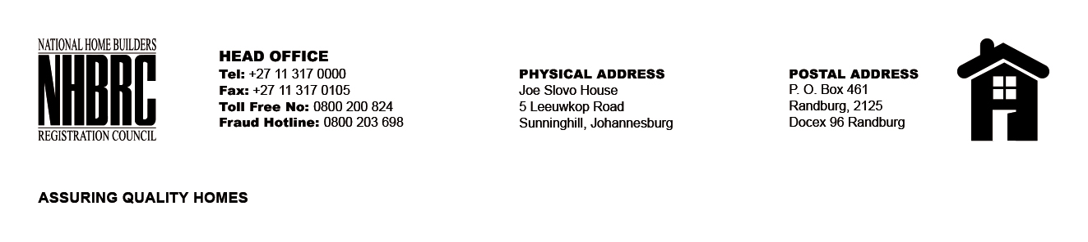

BID NUMBER: NHBRC 10/2023
CLOSING DATE: 23 JANUARY 2024 @ 11H00

BID DESCRIPTION: REQUEST FOR PROPOSALS: ESTABLISHMENT OF A PANEL OF SERVICE PROVIDERS TO PERFORM CONTRUCTION MATERIAL TESTING SERVICES FOR A PERIOD OF FIVE (5) YEARS

BLOEMFONTEIN

NO. | NAME OF BIDDER
1. | IKAGENG LESEDI TRADING ENTERPRISE CC
TOTAL: 1

