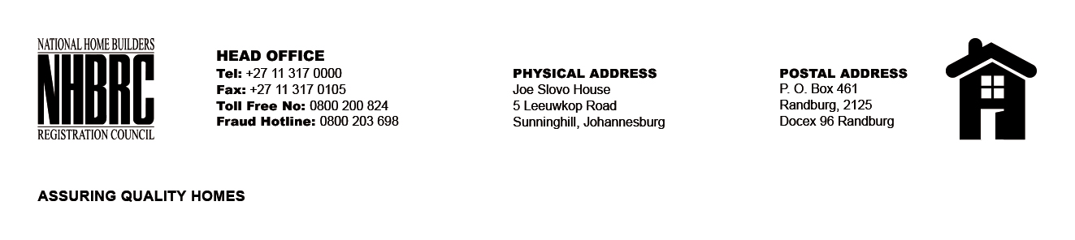

OPENING REGISTER

BID NUMBER : NHBRC 10/2023_EC Port Elizabeth
CLOSING DATE : 23 January 2023 @ 11h00

BID DESCRIPTION: REQUEST FOR PROPOSALS: ESTABLISHMENT OF A PANEL OF SERVICE PROVIDERS TO PERFOM CONSTRUCTION MATERIAL TESTING SERVICES TO THE NHBRC FOR A PERIOD OF FIVE (05) YEARS.

NO. | NAME OF BIDDERS | PRICE (INCL. VAT)
1. | Langa Geotechnical Services | N/A
2. | Phezulu Geotechnical Civils cc | N/A
TOTAL BIDS RECEIVED |  | 02

