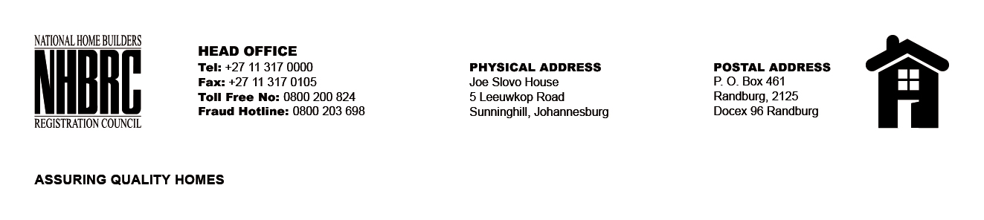

OPENING REGISTER
BID NUMBER : NHBRC 03/2023: Klerksdorp
CLOSING DATE : 09 October 2023 @ 11H00

BID DESCRIPTION: APPOINTMENT OF A SERVICE PROVIDER TO PROVIDE
SUITABLE OFFICE ACCOMMODATION AND PARKING FACILITIES FOR THE KLERKSDORP
OFFICE FOR A LEASE PERIOD OF NINE (09) YEARS, ELEVEN (11) MONTHS

NO. | NAME OF BIDDERS | TOTAL BID PRICE (INCL. VAT)
1. | Dangor Medical Centre | R 3 158 972.77
2. | SKG Africa | R 2 978 372.37
Total 02 Bids

