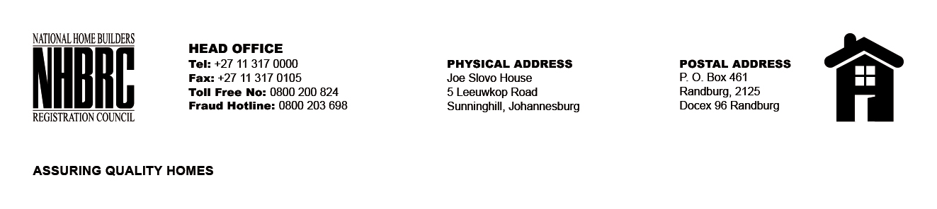

OPENING REGISTER

BID NUMBER : NHBRC 01/2022: (Western Cape)
CLOSING DATE : 14 April 2023 @ 11H00

BID DESCRIPTION: APPOINTMENT OF A PANEL FOR THE DESIGN, SUPPLY, AND INSTALLATION OF PROJECT (CONSTRUCTION) SIGNAGE BOARDS FOR A PERIOD OF THREE YEARS.

NO. | NAME OF BIDDERS
1. | Steyn Signage and Maintenance CC
2. | Mudau Picture Framers T/A FrameFun
3. | Custom Graphics Print
Total 3 Bids

