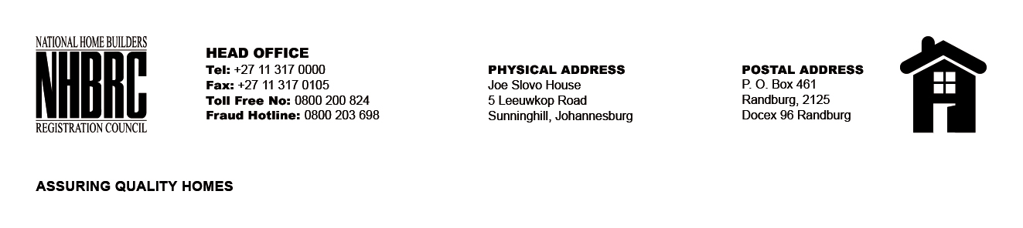

OPENING REGISTER

BID NUMBER : NHBRC 01/2022: (Eastern Cape)
CLOSING DATE : 17 April 2023 @ 11H00

BID DESCRIPTION: APPOINTMENT OF A PANEL FOR THE DESIGN, SUPPLY, AND INSTALLATION OF PROJECT (CONSTRUCTION) SIGNAGE BOARDS FOR A PERIOD OF THREE YEARS.

NO. | NAME OF BIDDERS
1. | Patcoline PTY LTD
2. | Mzwandile Michael Mtetho (Sikujongile Building Construction)
3. | Mudau Picture Framers T/A FrameFun
4. | Mysitoz Trading and Projects
5. | Nkhophele Holdings (PTY) LTD
Total 5 Bids

