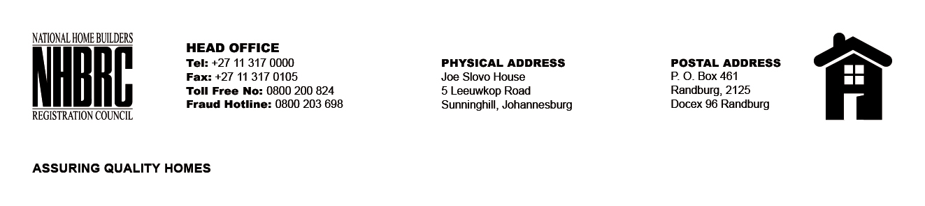

BID NUMBER: NHBRC 04/2023
CLOSING DATE: 14 AUGUST 2023 @ 11H00

BID DESCRIPTION: REQUEST FOR PROPOSALS: APPOINTMENT OF A PANEL OF INTERNAL AUDITORS TO THE NATIONAL HOME BUILDERS REGISTRATION COUNCIL (“NHBRC”) FOR A PERIOD OF THREE (03) YEARS. NORTH WEST (RUSTENBURG)

NO. | NAME OF BIDDER | PRICE (INCLUDING VAT)
1. | TIC AND MEND (PTY) LTD | PER AG RATES
2. | RAKOMA AND ASSOCIATES INC
3. | SAMBA SOLUTIONS INC
4. | NGUBANE AND COMPANY
5. | CHAPU CHARTERED ACCOUNTANTS INC
6. | MBE RISK ADVISORY & CONSULTING
7. | ARMS AUDIT & RISK MANAGEMENT SOLUTIONS
8. | MC AND N CONSTRUCTION AND SUPPLIES
9. | MDP CONSULTANTS (PTY) LTD
10. | MASEGARE AND ASSOCIATE INCORPORATED
11. | SNG GRANT THORNTON
12. | PWC
13. | SAB & T CHARTERED ACCOUNTANTS INC
14. | SHUMBA INCI
TOTAL: 14

