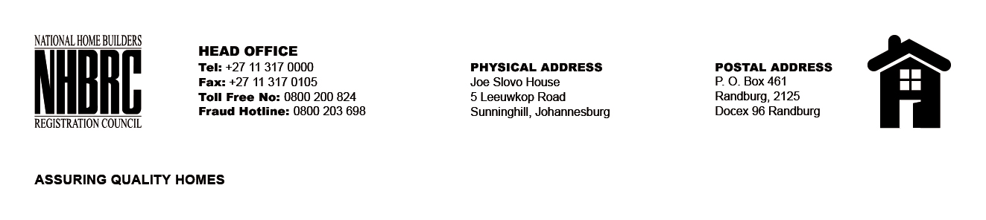

BID NUMBER : NHBRC 03/2023_NC (KIMBERLEY OFFICE)
CLOSING DATE : 08 AUGUST 2023 @ 11H00

BID DESCRIPTION: REQUEST FOR PROPOSALS: APPOINTMENT OF A SERVICE PROVIDE TO PROVIDE ACCOMMODATION AND PARKING FACILITIES FOR NHBRC (KIMBERLEY OFFICE) FOR A LEASE PERIOD OF NINE (09) YEARS, ELEVEN (11) MONTHS.

NO. | NAME OF BIDDERS | TOTAL BID PRICE (INCL. VAT)
1. | Prop West Investments (Pty) Ltd | R27 587 552.11
 | TOTAL BIDS RECEIVED | 01

