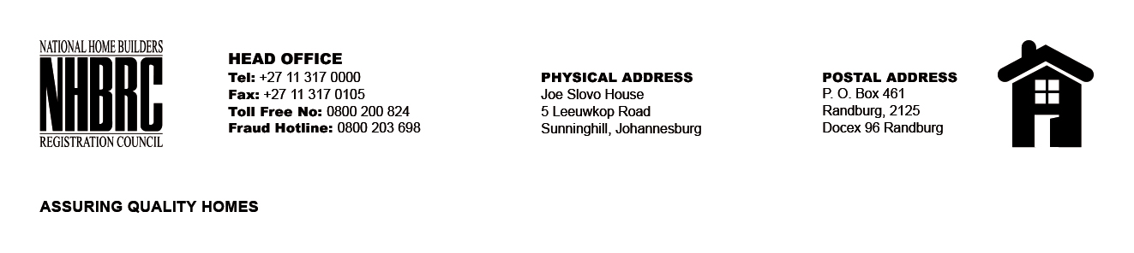

BID NUMBER: NHBRC 28/2019
CLOSING DATE: 25 February 2020 @ 11H00

BID DESCRIPTION: REQUEST FOR PROPOSALS: APPOINTMENT OF SERVICE PROVIDERS TO PROVIDE OFFICE ACCOMMODATION AND PARKING FACILITIES FOR NHBRC SUNNINGHILL, WOODMEAT OR RANDBURG OFFICE FOR A PERIOD OF FIVE (05) YEARS.

NO. | NAME OF BIDDER | BID PRICE
 | No Bids received
TOTAL: 0

