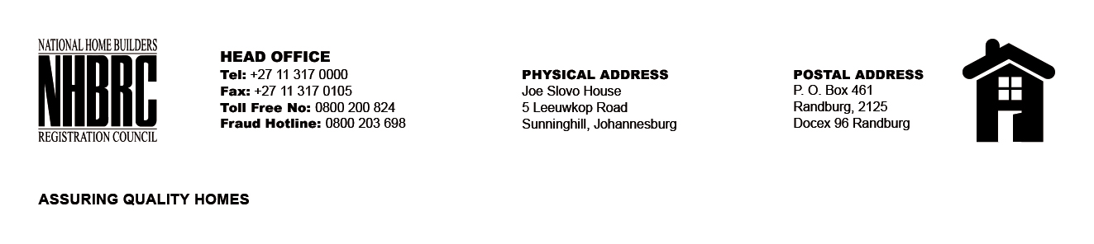

BID NUMBER : NHBRC 34/2017
CLOSING DATE : 11 AUGUST 2017 @ 11H00

BID DESCRIPTION: REQUEST FOR PROPOSALS FOR THE APPOINTMENT OF A SERVICE PROVIDER TO PROVIDE SUITABLE OFFICE ACCOMMODATION AND PARKING FACILITIES FOR A LEASE PERIOD OF FIVE (05) YEARS FOR THE NHBRC GEORGE OFFICE.

NO. | NAME OF BIDDER
1 | CLASSIC DIAMOND HOLDINGS CC
2 | RAINBOW PLACE PROPERTIES 29 (PTY) LTD
TOTAL: 02

