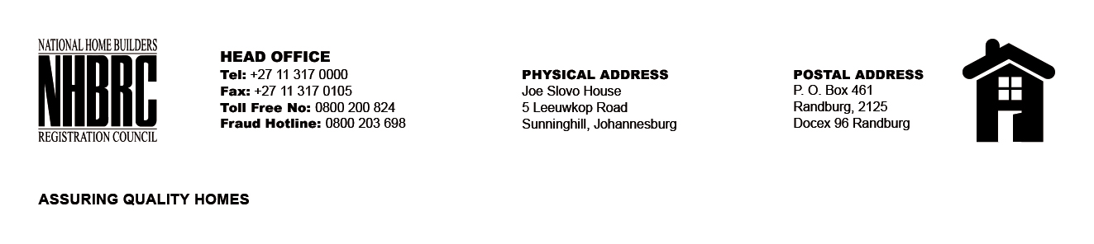

BID NUMBER: NHBRC 22/2016 – CLOSING DATE: 12 JANUARY 2017

REQUEST FOR PROPOSALS FOR THE APPOINTMENT OF A SERVICE PROVIDER TO PROVIDE ENTERPRISE ARRCTHITECTURE (EA) SERVICES FOR THE NHBRC FOR A PERIOD OF TWENTY FOUR (24) MONTHS.
NO. | NAME OF BIDDER
1. | Intellehub (Pty) Ltd
2. | Matsei Technologies & Consulting and TriVector
3. | Ingenious Strides Business Consulting (Pty) Ltd
4. | Real IRM Solutions (Pty) Ltd
5. | Ernst & Young Advisory Services
6. | Business Connexion (Pty) Ltd
7. | E Software Solutions (Pty) Ltd
8. | Hava Projects Management (Pty) Ltd
9. | Knotion Consulting (Pty) Ltd
10. | African Proficient Software (Pty) Ltd
11. | PriceWaterHouseCoopers INC
TOTAL: 11

